**Experiment: 3.2**

**Student Name:** ADITYA RAJ **UID:** 21BCS8948

**Branch:** CSE **Section/Group:** 703 A

**Semester:** 3rd **Date of Performance:** 07/11/2022

**Subject Name:** DBMS **Subject Code:** 21CSH214

**Aim of the Experiment:** Design a package for the university registrar's office to store the details of students and their results as well.

## Program Code:

CREATE TABLE Students( Rollno INT NOT NULL,

NAME VARCHAR(20) NOT NULL, AGE INT NOT NULL,

Address CHAR (25), res_Marks INT NOT NULL, PRIMARY KEY (Rollno)

);

INSERT INTO Students (Rollno,NAME,AGE,Address,res_Marks) VALUES (1, 'Shaw', 20, 'UP', 90 );

INSERT INTO Students (Rollno,NAME,AGE,Address,res_Marks) VALUES (2, 'Param', 19, 'Delhi', 89 );

INSERT INTO Students (Rollno,NAME,AGE,Address,res_Marks) VALUES (3, 'Yash', 20, 'Delhi', 88 );

INSERT INTO Students (Rollno,NAME,AGE,Address,res_Marks) VALUES (4, 'Deepak', 20, 'Mumbai', 88 );

INSERT INTO Students (Rollno,NAME,AGE,Address,res_Marks) VALUES (5, 'Karan', 20, 'Punjab', 89.5 );

INSERT INTO Students (Rollno,NAME,AGE,Address,res_Marks)

VALUES (3624, 'Raghav Nagpal', 21, 'Rajasthan', 93.0 ); Select * from Students;

CREATE OR REPLACE PACKAGE Stud_info AS

-- Adds a customer

PROCEDURE addStudents(c_Rollno Students.Rollno%type, c_name Students.Name%type, c_age Students.age%type, c_Address Students.Address%type,

c_Marks Students.res_Marks%type);

END Stud_info;

/

CREATE OR REPLACE PACKAGE BODY Stud_info AS

PROCEDURE addStudents(c_Rollno Students.Rollno%type,

c_name Students.Name%type, c_age Students.age%type, c_Address Students.Address%type,

c_Marks Students.res_Marks%type) IS

BEGIN

INSERT INTO Students (Rollno,name,age,Address,res_Marks) VALUES(c_Rollno, c_name, c_age, c_Address, c_Marks);

END addStudents;

END Stud_info;

/

DECLARE

code Students.rollno%type:= 8; BEGIN

Stud_info.addStudents(7, 'Rajendra', 20, 'Africa', 88); END;

/

--Student's result and it's information Select * from Students;

drop table students;

## OUTPUT:

The output of the above program is serializing –

1. Creating the table-



1. Inserting the values in the table-

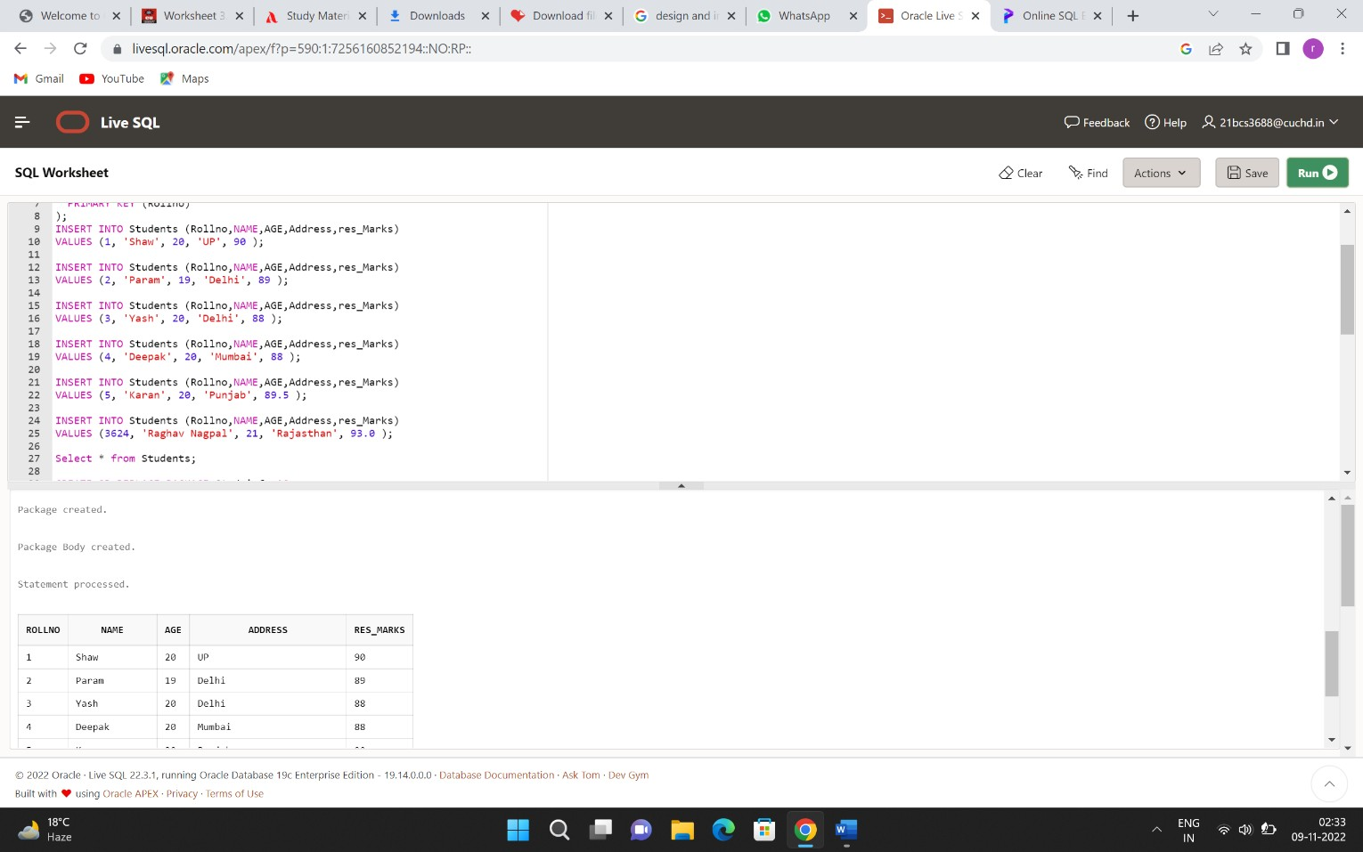

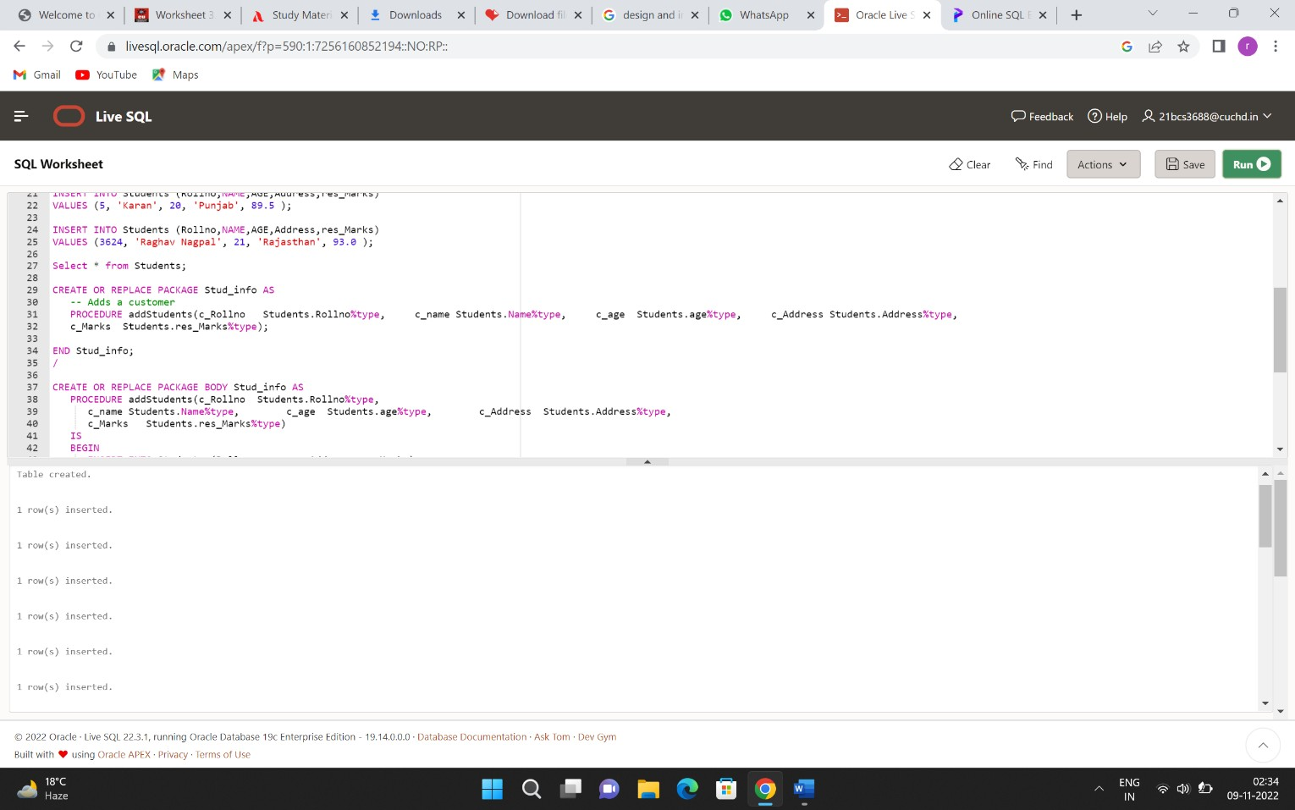

1. 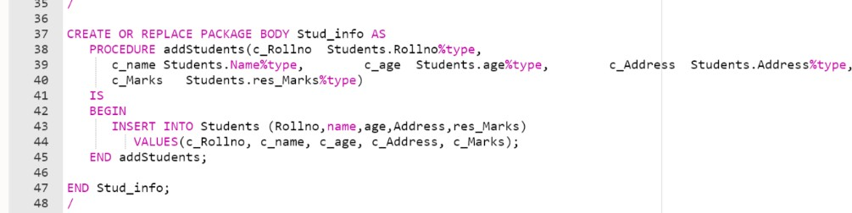Creating a package
2. Creating a package body

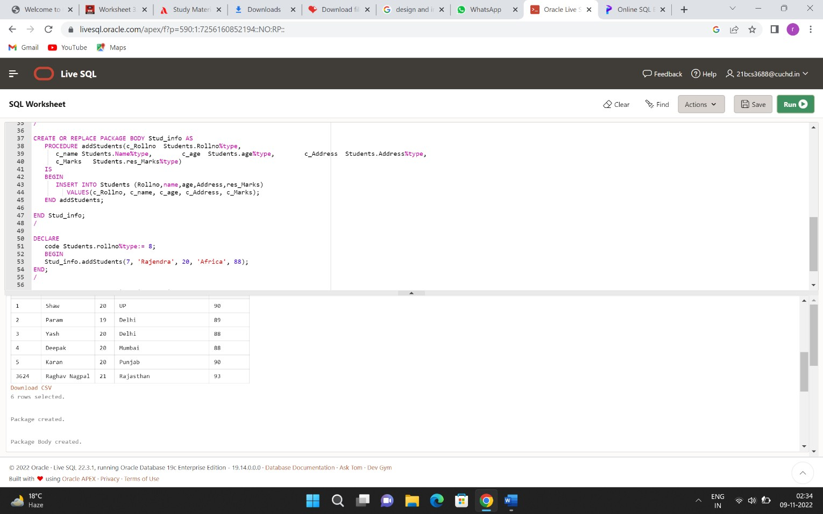

1. Updating the package result-

# COMPUTER SCIENCE & ENGINEERING





COMPUTER SCIENCE & ENGINEERING



